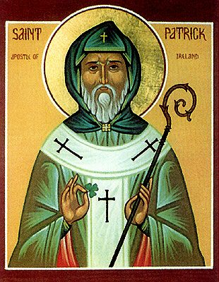
St. Patrick’s Co-Cathedral Parish
SUMMER 2019
Ministries for Weekend Masses
Please indicate the ministry you would like to assist with and the mass that you normally attend

Sunday Mass Time
Welcoming: Greet people as they enter church to 10:00 AM 7:00 PM
make them feel welcome.
Clean up pews after mass

Food: Bring Goodies for after mass 10:00 AM 7:00 PM

Hospitality Make coffee, juice and put out goodies 10:00 AM 7:00 PM
after mass, clean up after coffee time

Server: Assist priest during mass (training required) 10:00 AM 7:00 PM

Lector Proclaim the first or second reading and 10:00 AM 7:00 PM
the Prayers of the Faithful at mass

Eucharist Minister: Assist with the distribution of 10:00 AM 7:00 PM
Holy Communion.
(must be commissioned as EMHC)

Candle Bearer Carries a candle in procession at the beginning 10:00 AM 7:00 PM
and end of mass
Cross Bearer Carries the cross in procession at the beginning 10:00 AM 7:00 PM
and end of mass

NAME:_______________________________ EMAIL:__________________________
PHONE________________

Please email completed form to lstroman@theedge.ca

